
QUALITY ALERT

Customer: Seaway Date: March 18, 2024
Die: 4683 Colour: All
Type of Complaint: Seaway Reject

Q.A # Q.I.R # CUSTOMER NCR #

Description: the accessory groove was OUT of spec causing the accessories will not hold with the frame.
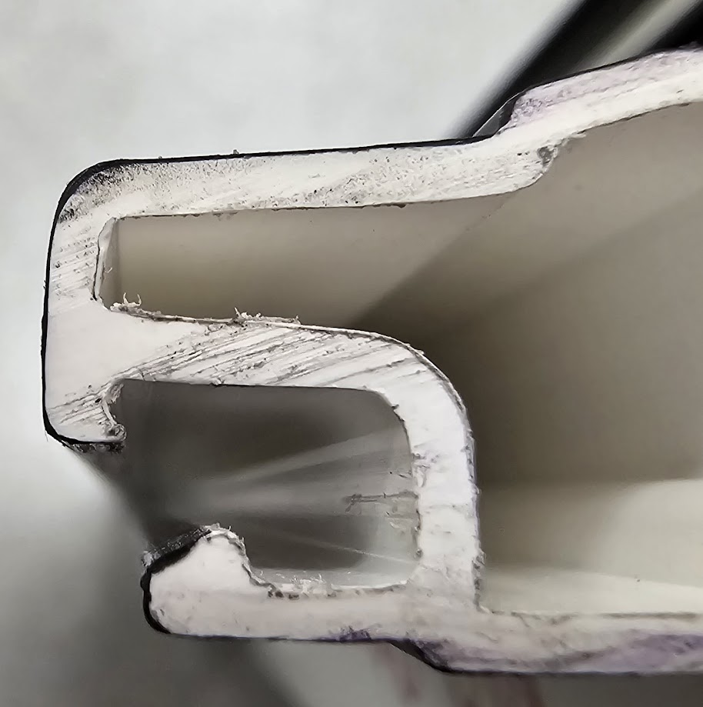
TOO SMALL

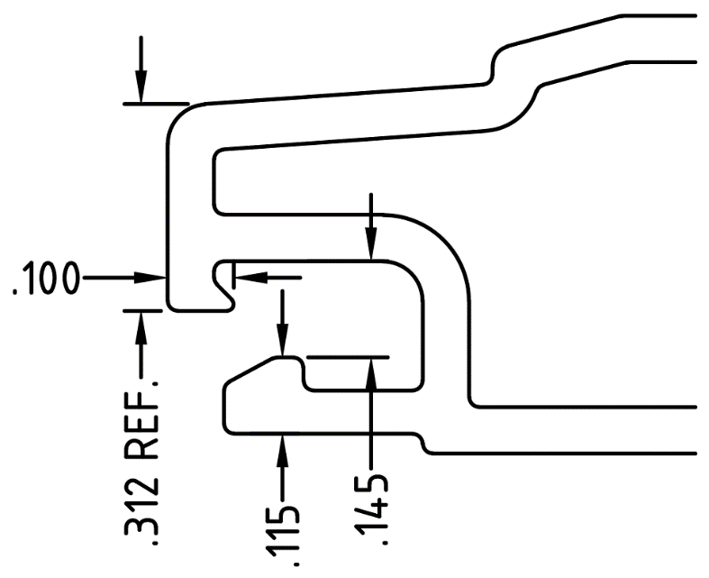

GAP OPEN

PLEASE MAKE SURE THE DIMENSION IN TOLERENCE ± 0.005” AND FIT SNUG WITH THE ACCESSORIES

BY SIGNING BELOW, YOU ACKNOWLEDGE THE PROBLEM ABOVE AND AGREE TO MONITOR THIS ISSUE IN FUTURE PRODUCTION RUNS.
DAY SHIFT |  | AFTERNOON SHIFT |  | NIGHT SHIFT
NAME | SIGNATURE | NAME | SIGNATURE | NAME | SIGNATURE

